1. Create a simple cloud software application for Property Buying & Rental process (In Chennai city) using any Cloud Service Provider to demonstrate SaaS

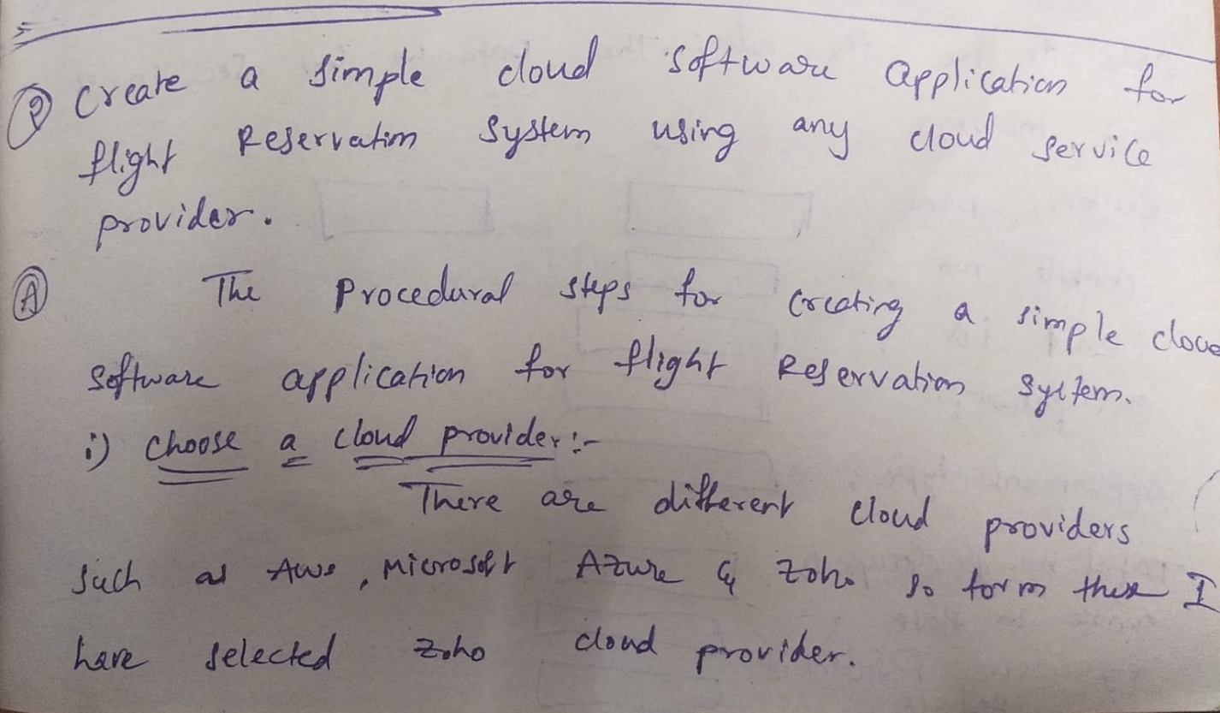**procedural steps:**

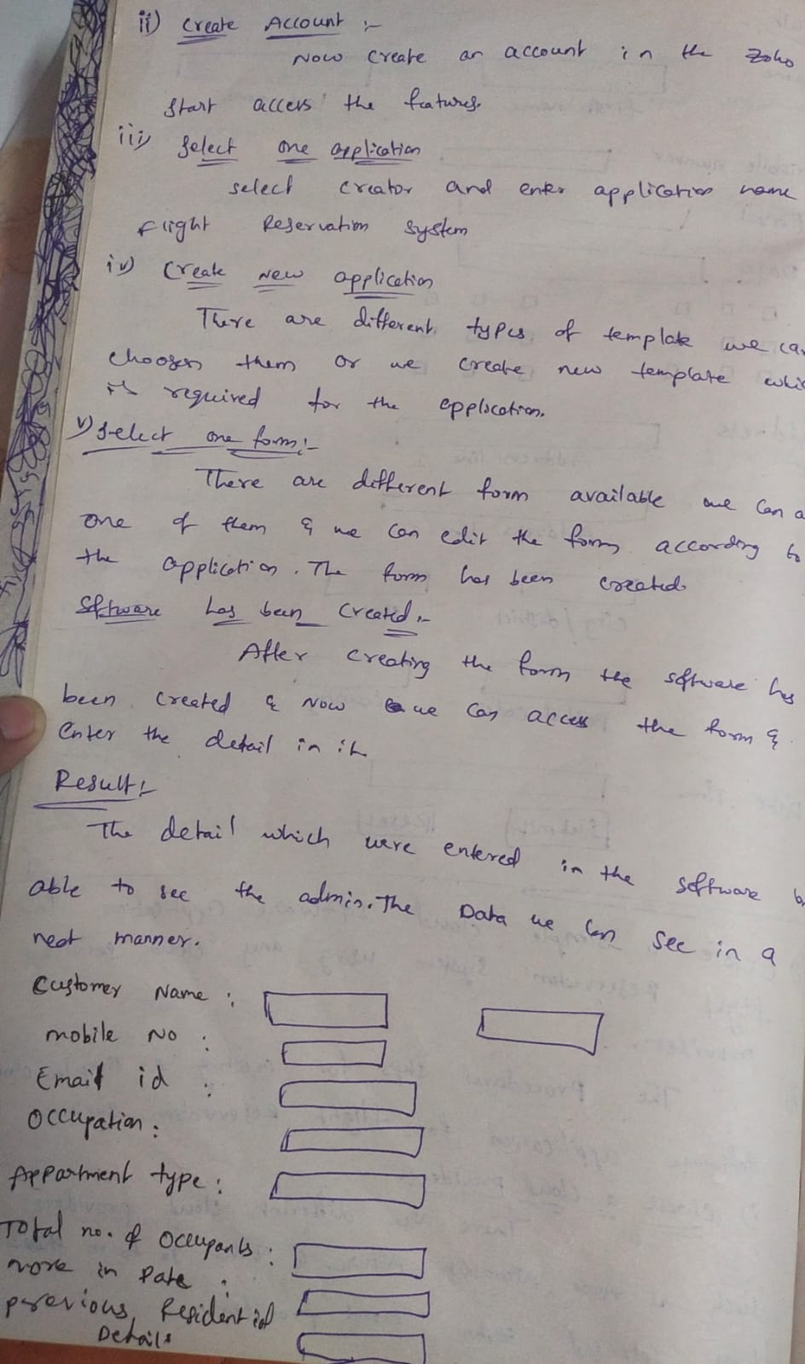

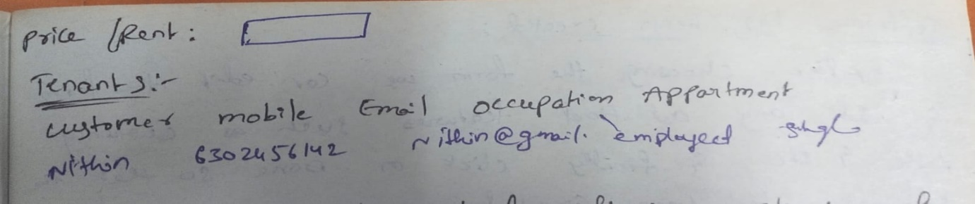

BUILDER FORM: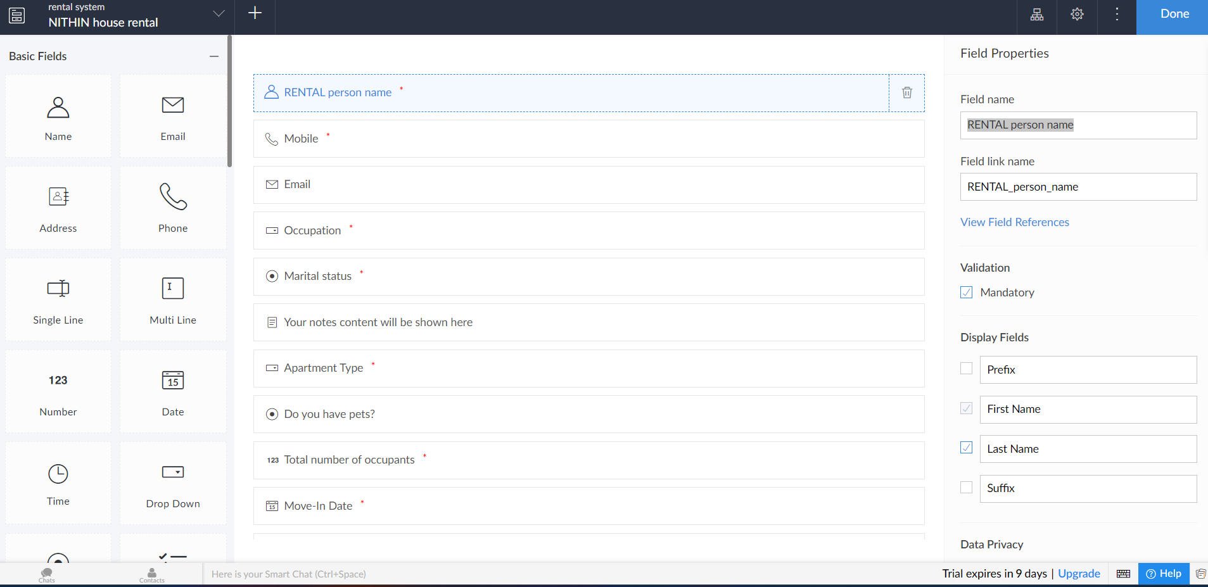

DETAILS ENTERING FORM:

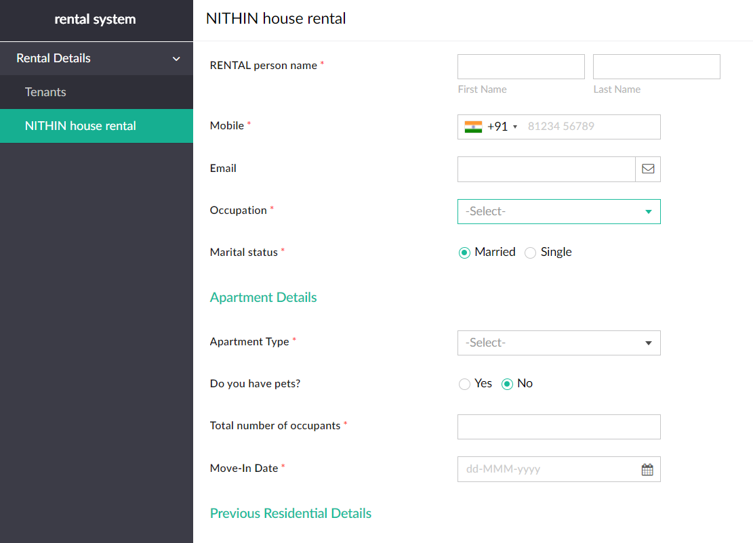

RESULT:



